Are You a Free American?
Or a US Citizen Subject?

Missouriassembly.org

Missouriassembly.org

Missouriassembly.org

Missouriassembly.org

Missouriassembly.org

Missouriassembly.org

Missouriassembly.org

Missouriassembly.org

Missouriassembly.org

Missouriassembly.org

YOUR DECLARED BIRTHRIGHT POLITICAL STATUS IS THE KEY TO FREEDOM.
CITIZENSHIP IS YOUR CHOICE!

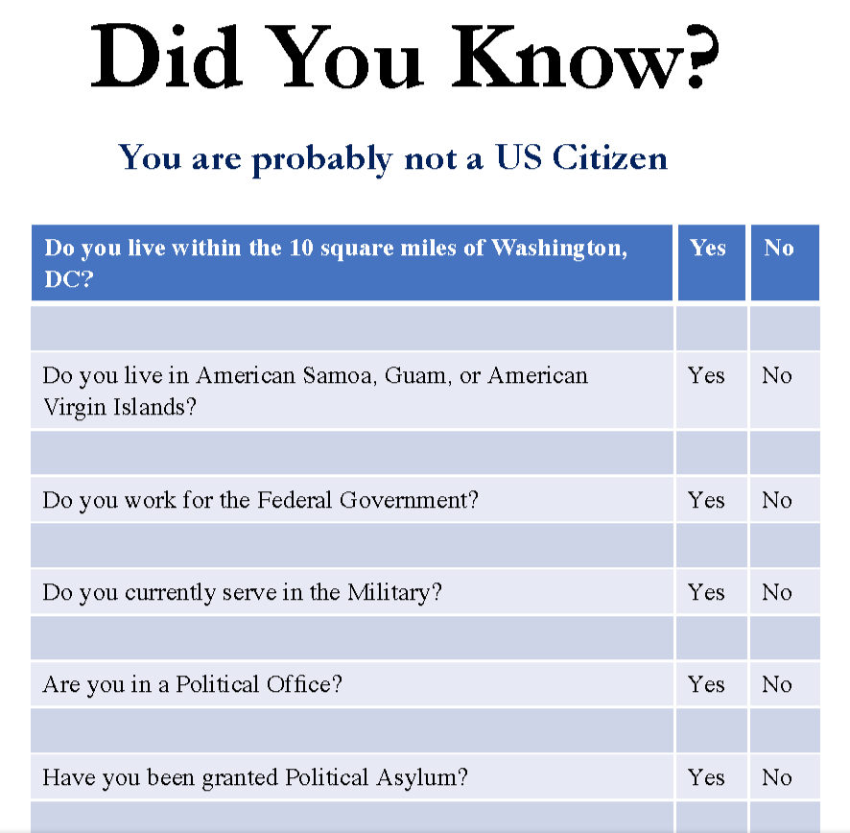
All parts of Government-
Federal, State and Local
Are CORPORATIONS
Check for yourselves the
Dunn and Bradstreet Corp. #s :
U.S .Government 052714196
U.S. Treasury 026661067
U.S. Dept .of State 026276622
IRS 040539587 I.R.S. 040539587
F.B.I. 878865674

STATE OF MISSOURI 073134579 061207536 Jefferson City, Mo. 034901342
Would you follow regulations
created by Burger King????

Would you pay corporate debt taxes to
to Pepsi ????????

PROTECT YOUR LIFE
PROTECT YOUR PROPERTY
RESTORE YOUR REPUBLIC
If you answered NO to these questions, you can free yourself from GOVERNMENT SLAVERY!
Join Your Missouri Assembly - Restore Lawful Government
Use this QR code on your cell phone for more information
All 50 Union States have assembled and we are moving forward to restore the republic.
Take back your birth right political status and join the Missouri Assembly.
The 14th Amendment made you a debt and regulation slave of Government.
Free yourself from the government chains that bind you!!!

